QUESTION:

PROJECT IDEA-The objective of this is machine learning project is to classify human facial expressions and map them to emojies.

You will built a convoulution neural network to recognize facial emotions.

Then you will map those emotions with the corresponding emojies or avathars.

**ANALYSIS**

**About Work and observation:**

Creating of emojies are done by using jupyter notebook,python and deep learning.

Here we used jupyter notebook for creating emojies

*we can create emojies directly on jupyter noterbook with their Unicode.

*Every emoji has a unique Unicode.

*We can use Unicode characters,CLDR names or python library emoji to print emojies.

*The basic Unicode of any emoji is U+XXXXX.

*When using Unicode with python, replace “+” with “000” from the Unicode and then prefix the Unicode with “\”.

*Every Unicode must contain 8 bits with the exclusion of U.

Example:

U+1F605 can be replaced into U0001F605

and when we are giving it as input we should give in the following format

print(“\U0001F305”)…

ADVANTAGES OF USING EMOJIES:

1. We can use emojies for expressing our emotions

For example: When we are happy instead of saying I’m happy we can use happy emoji.

1. These emojies are mainly used in social media platforms like whatsapp, instagram, twitter, telegram.

PICTURES OF EMOJIES IN INDIVIDUAL PLATFORMS:

Instagram:

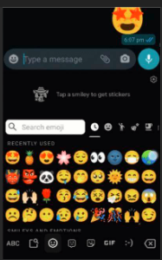

Twitter:



Facebook:

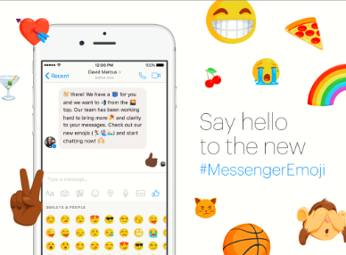

Whatsapp:

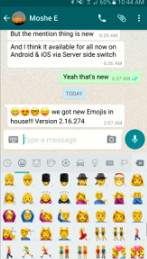

-------------------0------------------